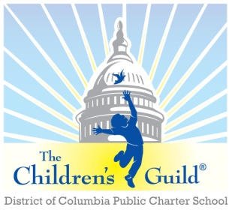
The Children’s Guild DC Charter School Board

Date: Monday, April 26, 2021
Time: 5:30 p.m.
Place: Zoom

Attendees | The Children’s Guild Staff
Robert Seabrooks  Marie Caputo  Melody Giles  Cleopatra Green-Clarke  Yolanda Lusane  Charles McNeill | Bryan Daniels  Aleisa Fries  Kathy Lane  Kimberly Neal

Minutes

- Call to Order – Mr. Seabrooks (5:54 pm)
- Approval of Bylaws – Mr. Seabrooks
The changes to the bylaws have been reviewed and approved by the Board.
- Adjourn – Mr. Seabrooks (6:00 pm)

