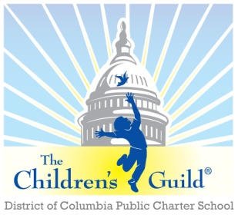
The Children’s Guild DC Charter School Board

Date: Monday, August 8, 2022
Time: 6 – 8 p.m.
Place: Zoom

AGENDA

- Call to Order – Mr. Seabrooks (6:05 pm)
- Public Comment – Mr. Seabrooks (6:05-6:10)

- Introduction and Onboarding New Board Member-Casandra D. Blassingame- Mr. Seabrooks (6:10-6:15)
- Approval of Minutes – Mr. Seabrooks (see attached) (6:15-6:20)
April 4, 2022, and June 6, 2022

- FY22 and Current Period Financial Report – Mr. Gordon (6:20-6:50)
- ‘FY23 Budget Approval’
- New CFO introduction- Chris Zimmerman

- Conflict of Interest forms – Board Members (6:50-6:55)

- Principal’s Report – Mr. Daniels (6:55-7:15)

- Board Membership- Mr. Seabrooks (7:15-7:25)
- Proposed initiatives to increase Board membership
- “Education Board Partners” Update- Mr. Curran
- Committee Meeting Agendas, standing meeting calendar and Minutes

- Facility Update- Mr. Seabrooks/Mr. Daniels (7:25-7:30)
- Roof (Report/Repair status update)
- Potential Preschool Partnerships

- Marketing and Branding for Recruitment Window- Mr. Turner (7:30-7:45)

- Committee Reports – Mr. Seabrooks (7:45-7:55)
  - Governance Committee - Michael Curran (Chair)
- Board member officer appointment(s)
- Potential new Board member – Mark Lerner (resume attached)
  - Marketing, Enrollment, Finance & Facilities Committee (MEFF) – Ms. Lusane (Chair)
    - Board Member video on why they are Board Members
  - Parent Engagement, Academic Excellence & Compliance Committee (PEAC) – Ms. Thomas (Chair)
- Parent/Teacher platforms for consideration

- Other Business – Mr. Seabrooks (7:55-8:00)
- Adjourn – Mr. Seabrooks (8:00 pm)

