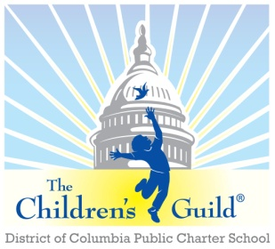
The Children’s Guild DC Charter School Board

Date: Monday, February 12, 2024
Time: 6 – 8 p.m.
Place: Zoom

AGENDA

- Call to Order – Mr. Seabrooks (6:00 pm)
- Public Comment – Mr. Seabrooks (6:00-6:05)
- Review Minutes – Mr. Seabrooks (see attachments) (6:05 – 6:10 pm)
- Approve minutes for August 07, 2023.
- Approve minutes for November 13, 2023.

- Principal’s Report – Mr. Medley (6:10 – 6:55 pm)

- Board membership & meetings– Mr. Seabrooks (6:55-7:10pm)
- Updates

- Children’s Guild updates + upcoming events, etc. – Mr. Johnson (7:10-7:30)
- Other Business (if any)

- Financial Report – Mr. Chris Zimmerman (7:30 – 7:50 pm)
  - Review Current Period

- Other Business (7:50 – 8:00 pm)
  - Current Enrollment by school and Recruitment Strategy – Mr. Daniels
  - Other Business (if any)
- Adjournment – Mr. Seabrooks (8:00 pm)

