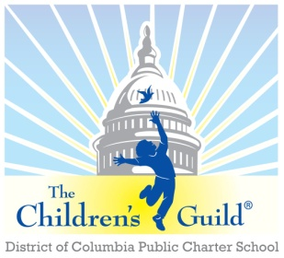
The Children’s Guild DC Charter School Board

Date: Monday, February 1, 2024
Time: 6 – 8 p.m.
Place: Zoom

Attendees | The Children’s Guild Staff
Robert Seabrooks  Miguel Vicente  Angelo Wong  Jess Rios | Hughes Johnson  Roneisha Estep-Franklin  Chris Zimmerman  Bryan Daniels  Dr. Tanna Jackson  Francis Medley  Franchesca Carter
Meeting Minutes

- Call to Order – Mr. Seabrooks
The Children’s Guild D.C Charter School Board meeting was called to order at 6:05 p.m.
- Public Comment – Mr. Seabrooks
Mr. Seabrooks – Happy Black History Month

- Approval of Minutes – Mr. Seabrooks
Minutes could not be approved due to not having a quorum.

- FY23 and Current Period Financial Report – Mr. Zimmerman

Mr. Zimmerman reported:
- Q2 Financial Report
  - $641,000 Negative
  - Waiting for OSSE to catch up with SPED funding
- Grant and Support Revenues
  - Funding coming to a close

- Principal’s Report – Mr. Medley

TCGDC Designing Excellence:

- Qualitative School Review (QSR)
- Observed using the Danielson framework
- Observed Domains 2 & 3
- Last review was SY 2018-19
- Original proficiency score was 78%.
- SY23 – Proficiency Score 95%
- Distinguished in managing student behavior
- 100% - Creating an environment of respect and rapport

- Snow Day Calendar
- Last Snow Day was exhausted on January 19th.
- March Calendar adjusted to accommodate
- March 14th – Snow Make-up Day

- I-Ready Testing/CAPE Testi
- Started January 23rd
- 50% growth target already met
- PARCC is now called CAPE
- Mrs. Carter is currently in training for the new system.

- School Culture
  - Winter Wonderland 15 minutes supper
  - Pastries with Parents
- SpEd Report
  - TOTAL 128 SPED Students
- Enrollment/Recruitment
  - 278 is the current enrollment.
  - Rise in the number of kindergarten students

- Marketing and Branding for Recruitment Window- Mr. Daniels/Miguel

- 35 students on the waiting list
- 30 applications in the queue
- Reaching out to the Latino/Hispanic Community

- Committee Reports – Mr. Seabrooks
- No Committee Updates

- Other Business – Mr. Seabrooks
- No other business

- Adjourn – Mr. Seabrooks
The Children’s Guild D.C. Charter School meeting was adjourned at 6:47pm

