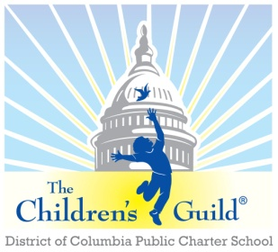
The Children’s Guild DC Charter School Board

Date: Monday, September 9
Time: 6 – 8 p.m.
Place: Zoom

AGENDA

- Call to Order – Mr. Seabrooks (6:00 pm)
- Public Comment – Mr. Seabrooks (6:00-6:05)
- Review Minutes – Mr. Seabrooks (see attachments) (6:05 – 6:10 pm)
- Approve minutes for August 05, 2024.

- Introduction of the new Board members (6:10 – 6:20 pm)
  - Tiphanie Edwards
  - Nina Lattimore
  - Rodrick Thompson

- Principal’s Report – Mr. Medley (6:20 – 6:55 pm)

- Children’s Guild updates + upcoming events, etc. – Mr. Johnson (6:55 - 7:15)
- Other Business (if any)

- Financial Report – Mr. Lou Hubner (7:15 – 7:45 pm)
  - Review Current Period

- Other Business (7:45 – 8:00 pm)
  - Charter Renewal – Mr. Daniels
    - Adding PreK
  - Other Business (if any)
- Adjournment – Mr. Seabrooks (8:00 pm)

