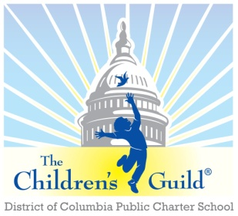
The Children’s Guild DC Charter School Board

Date: Monday, May 12, 2025
Time: 6 – 8 p.m.
Place: Zoom

Attendees | The Children’s Guild Staff Attendees
Robert Seabrooks  Angelo Wong (Absent)  Jess Rios  Roderick Thompson  Tiphanie Edawards  Lou Hubner (Absent)  Elizabeth Garcia  Nina Lattimore  Andrew Simone  Myesha Holmes (Absent) | Hughes Johnson  Roneisha Estep-Franklin (Absent)  Bryan Daniels  Dr. Tanna Jackson  Franchesca Carter  Kendall Knox  Shelby Camphor  Ashley Posey (Absent)
Meeting Minutes

- Call to Order – Mr. Seabrooks
The Children’s Guild D.C Charter School Board meeting was called to order at 6:15 p.m.
- Public Comment – Mr. Seabrooks
Mr. Seabrooks – Announcements of change and steps of preparation for moving forward in the 25-26 SY.

- Other Business – Mr. Seabrooks
- No other business

- Adjourn – Mr. Seabrooks
The Children’s Guild D.C. Charter School meeting was adjourned at 6:31pm

