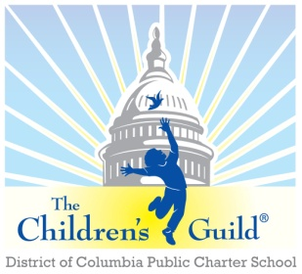
The Children’s Guild DC Charter School Board

Date: Monday, November 10, 2025
Time: 6 – 8 p.m.
Place: Zoom

AGENDA

- Call to Order – Mr. Roderick Thompson (6:00 pm)
- Public Comment – Mr. Roderick Thompson (6:00 pm)
- Review Minutes – Mr. Roderick Thompson (see attachments) (6:05 – 6:10 pm)
- Approve minutes for September 2025

- School report (6:10 – 6:30 pm)
  - Chanei Clemons

- Children’s Guild updates + upcoming events, etc. – Mr. Hughes Johnson (6:30 – 6:40 pm)
- Other Business (if any)
- Census and Staffing
- Playground update

- Financial Report – Mr. Josh Sutherland (6:40 – 7:00 pm)
  - Budget update

- Other Business
  - Other Business (if any)
- Adjournment – Mr. Roderick Thompson

