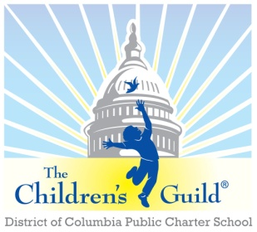
The Children’s Guild DC Charter School Board

Date: Monday, September 8, 2025
Time: 6 – 8 p.m.
Place: Zoom

AGENDA

- Call to Order – Mr. Seabrooks (6:15 pm)
- Public Comment – Mr. Seabrooks (6:15-6:20)

- Nomination of New Board Chair
- Review Minutes – New Board Chair (see attachments) (6:05 – 6:10 pm)
- Approve minutes for May 2025

- Introduction of Principal and school report
  - Chanei Clemons

- Children’s Guild updates + upcoming events, etc. – Mr. Johnson (7:10-7:30)
- Other Business (if any)
- Playground update

- Financial Report – Mr. Josh Sutherland (7:30 – 7:50 pm)
  - Review last years performance and upcoming budget

- Other Business (7:50 – 8:00 pm)
  - Other Business (if any)
- Adjournment – Mr. Seabrooks (8:00 pm)

